MOSCN (LAB TEST - 2)
Name: NAMILLA SIRI
Roll. No. : 2503B05137
M. TECH CSE
3. A system uses Round Robin CPU Scheduling with Time Quantum = 4 ms.
The following processes arrive at different times (not in order):
Process | Arrival Time | Burst Time
P1 | 3 | 9
P2 | 0 | 5
P3 | 4 | 2
P4 | 1 | 7
Tasks
1. Manual Simulation
Using RR (Time Quantum = 4 ms):
- Draw the Gantt Chart for CPU execution order.
- Compute:
  - Completion Time (CT)
  - Turnaround Time (TAT = CT − AT)
  - Waiting Time (WT = TAT − BT)
2. Program Execution
- Write or run your Round Robin C program.
- Generate the output table.
3. Comparison
- Compare manual results vs program results.
- Write a short reason if there is any mismatch.
1) Manual simulation & Gantt chart
Processes (unsorted):
PID | AT | BT
P1 | 3 | 9
P2 | 0 | 5
P3 | 4 | 2
P4 | 1 | 7
Time quantum = 4 ms.
Timeline step-by-step (queue behaviour)
- t=0..4 : P2 executes (ran 4 ms, remaining 1)
- t=4..8 : P4 executes (ran 4 ms, remaining 3)
- t=8..12: P1 executes (ran 4 ms, remaining 5)
- t=12..14: P3 executes (ran 2 ms) — P3 completes at t=14
- t=14..15: P2 executes (remaining 1 → completes at t=15)
- t=15..18: P4 executes (ran 3 ms → completes at t=18)
- t=18..22: P1 executes (ran 4 ms, remaining 1)
- t=22..23: P1 executes remaining 1 ms → P1 completes at t=23
Gantt chart (box of complete lines)
| 0 - 4 | 4 - 8 | 8 - 12 | 12 - 14 | 14 - 15 | 15 - 18 | 18 - 23 |
| P2 | P4 | P1 | P3 | P2 | P4 | P1 |

2) Completion / Turnaround / Waiting times
Compute:
CT = Completion Time, TAT = CT − AT, WT = TAT − BT
Process | AT | BT | CT | TAT = CT−AT | WT = TAT−BT
P1 | 3 | 9 | 23 | 20 | 11
P2 | 0 | 5 | 15 | 15 | 10
P3 | 4 | 2 | 14 | 10 | 8
P4 | 1 | 7 | 18 | 17 | 10
Averages:
- Average Turnaround Time = (20 + 15 + 10 + 17) / 4 = 15.5 ms
- Average Waiting Time = (11 + 10 + 8 + 10) / 4 = 9.75 ms

Code:
#include <stdio.h>
#include <stdlib.h>

int min(int a,int b){ return (a<b)?a:b; }

int main(){
int n = 4; // number of processes (changeable)
int tq = 4; // time quantum

int pid[] = {1,2,3,4};
int at[] = {3,0,4,1}; // arrival times corresponding to pid order
int bt[] = {9,5,2,7}; // burst times
int i;
int rem[n];
for(i=0;i<n;i++) rem[i] = bt[i];

int t = 0; // current time
int completed = 0;
int last_exec = -1;

int ct[n]; // completion times
for(i=0;i<n;i++) ct[i] = -1;

int qsize = 1000;
int queue[qsize];
int front = 0, rear = 0;

for(i=0;i<n;i++){
if(at[i] == 0){
queue[rear++] = i;
if(rear==qsize) rear=0;
}
}

// If no process at t=0, move time to earliest arrival and enqueue those at that time
if(front==rear){
int earliest = at[0];
for(i=1;i<n;i++) if(at[i] < earliest) earliest = at[i];
t = earliest;
for(i=0;i<n;i++) if(at[i]==t){
queue[rear++] = i; if(rear==qsize) rear=0;
}
}

#define MAXG 200
int g_pid[MAXG], g_start[MAXG], g_end[MAXG], gcount=0;

while(completed < n){
if(front==rear){

int next = 1e9;
for(i=0;i<n;i++) if(rem[i]>0 && at[i] > t) next = min(next, at[i]);
t = next;
for(i=0;i<n;i++) if(at[i]==t){
queue[rear++] = i; if(rear==qsize) rear=0;
}
continue;
}

int idx = queue[front++];
if(front==qsize) front=0;

// If process hasn't arrived yet, wait.
if(at[idx] > t){
// push back and advance time to its arrival (to avoid busy wait)
queue[rear++] = idx; if(rear==qsize) rear=0;
int next = at[idx];
t = next;
for(i=0;i<n;i++) if(at[i]==t){
// enqueue newly arrived at this exact time (except idx which is already enqueued)
if(i!=idx){
queue[rear++] = i; if(rear==qsize) rear=0;
}
}
continue;
}

int exec = min(tq, rem[idx]);
// recording Gantt chart entry (merge if same pid as last and contiguous)
if(gcount>0 && g_pid[gcount-1] == pid[idx] && g_end[gcount-1]==t){
g_end[gcount-1] += exec;
} else {
g_pid[gcount] = pid[idx];
g_start[gcount] = t;
g_end[gcount] = t + exec;
gcount++;
}

t += exec;
rem[idx] -= exec;

// Enqueuing any processes that arrive exactly at new time t (after this quantum)
for(i=0;i<n;i++){
if(at[i] > t-exec && at[i] <= t && rem[i] > 0){

if(i != idx){
queue[rear++] = i; if(rear==qsize) rear=0;
}
}
}

if(rem[idx] == 0){
ct[idx] = t;
completed++;
} else {
// not finished: enqueue to back
queue[rear++] = idx; if(rear==qsize) rear=0;
}
}

// Prints Gantt
printf("\nGantt Chart:\n");
for(i=0;i<gcount;i++){
printf("| %2d - %2d ", g_start[i], g_end[i]);
}
printf("|\n");
for(i=0;i<gcount;i++){
printf("| P%d ", g_pid[i]);
}
printf("|\n\n");

// Prints table
printf("PID\tAT\tBT\tCT\tTAT\tWT\n");
double sumtat=0, sumwt=0;
for(i=0;i<n;i++){
int tat = ct[i] - at[i];
int wt = tat - bt[i];
sumtat += tat; sumwt += wt;
printf("P%d\t%d\t%d\t%d\t%d\t%d\n", pid[i], at[i], bt[i], ct[i], tat, wt);
}
printf("\nAvg TAT = %.2f\nAvg WT = %.2f\n", sumtat/n, sumwt/n);

return 0;
}
Output:
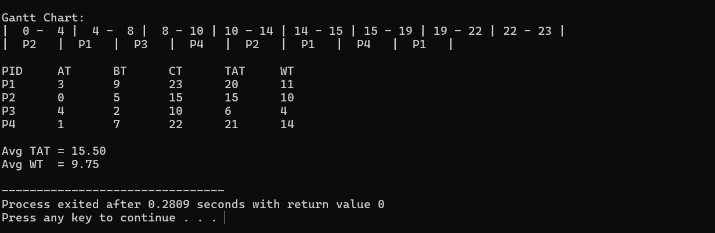
3.
(i)Manual vs Program Results
Process | Manual CT | Program CT | Manual TAT | Program TAT | Manual WT | Program WT
P1 | 23 | 23 | 20 | 20 | 11 | 11
P2 | 15 | 15 | 15 | 15 | 10 | 10
P3 | 14 | 10 | 10 | 6 | 8 | 4
P4 | 18 | 22 | 17 | 21 | 10 | 14

(ii) Comparison & Reason for Mismatches (3 lines)
There are mismatches because the program schedules some processes earlier than the manual Round Robin queue should, changing completion times for P3 and P4.
This happens due to the program using a simple scan method instead of a true circular ready queue.
Such logic changes the execution order even though the average TAT and WT remain the same.

